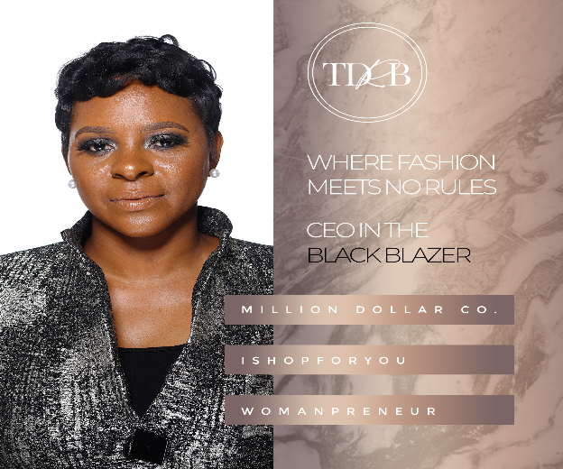
Hello, we are delighted that you have chosen The Dressing Room Boutique to style you! We look forward to working with you to change, update, or simply add to your closet. Please read the contract below.
Personal Stylist for a Day- After the consultation fee of $25, customer will be able to enjoy the luxury of having their own personal stylist for a day. Stylist will shop for customer based on the specific needs/wants from the consultation. Personal styling is $75. Total for this service is a flat rate fee of $100. Consultation and personal styling fee is due before customer scheduled appointment or services rendered.
Pictures- By signing this contract customer is agreeing to take photos of their item(s) from The Dressing Room Boutique and upload them to our page/group in an effort to grow our social media platforms. Customer is also giving us the right to post and publish photos on our website, social media, and all media platforms.
Return Policy- The Dressing Room Boutique has a no refund and all sales are final policy. However, if an item is not useable, the owner will allow “ONE” return or exchange for an item from The Dressing Room Boutique, No Exceptions!
Cancellation Policy- Cancellations will be made within 24 hours before appointment. There is no refund for consultations or personal styling fees. If customer makes an appointment with The Dressing Room Boutique, please make sure that customer can keep the scheduled appointment.

By signing The Dressing Room Boutique Contract the customer is agreeing to information above and will adhere to all policies, fees, and instructions.

_______________________________ ______________________________
TDRB, Owner/Stylist TDRB, Customer

